1. Go to TCode SE16

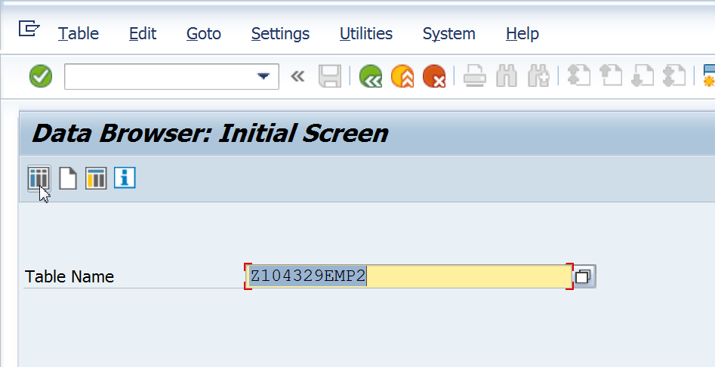

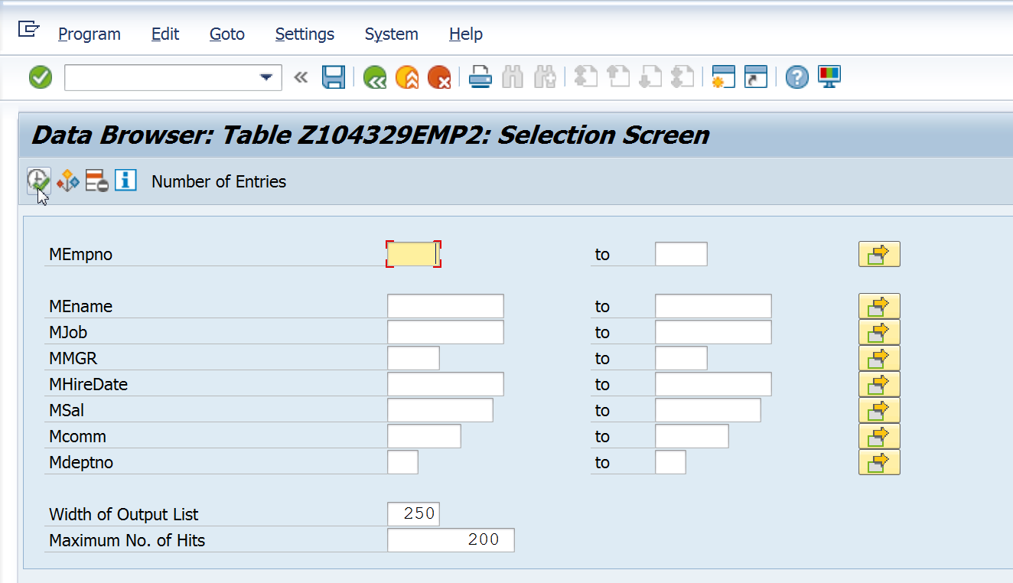

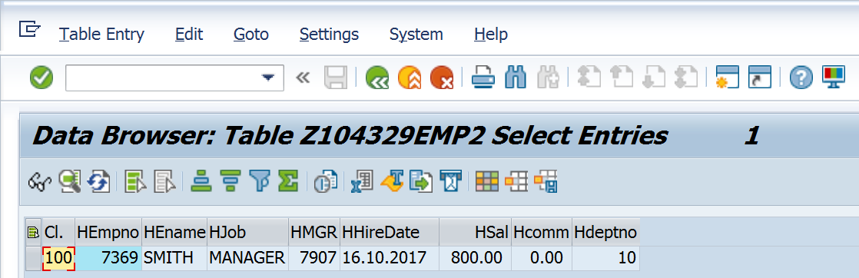

Go back till you reach the previous screen. Create entries.

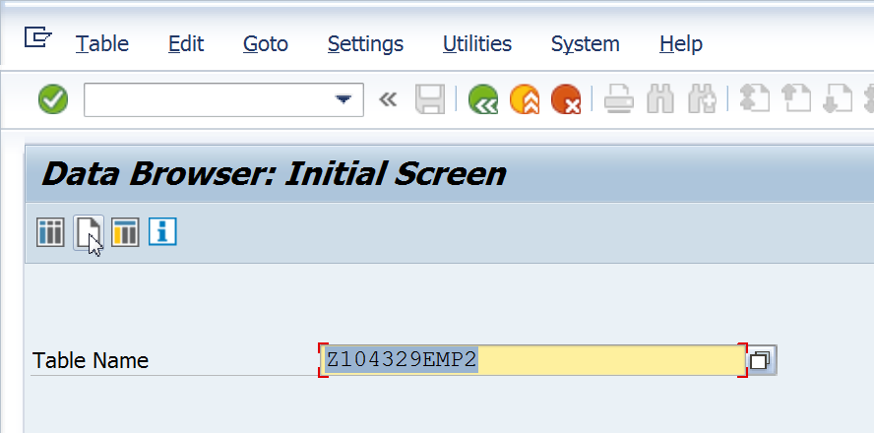

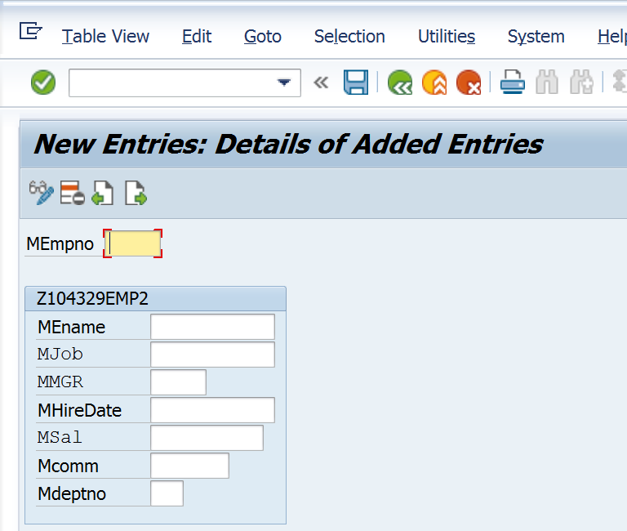

In the above case, 2 screens are seen because Table Maintenance Generator with two screens has been created for the above table.